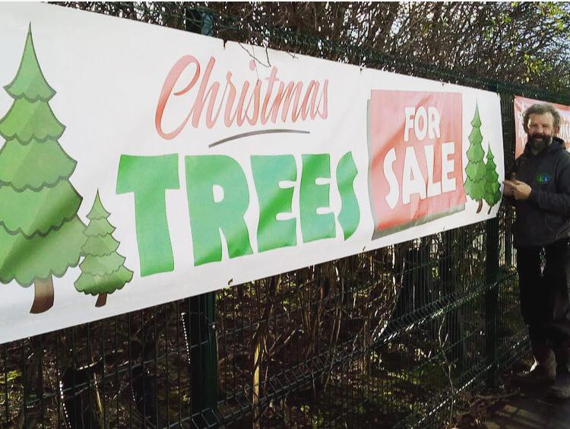  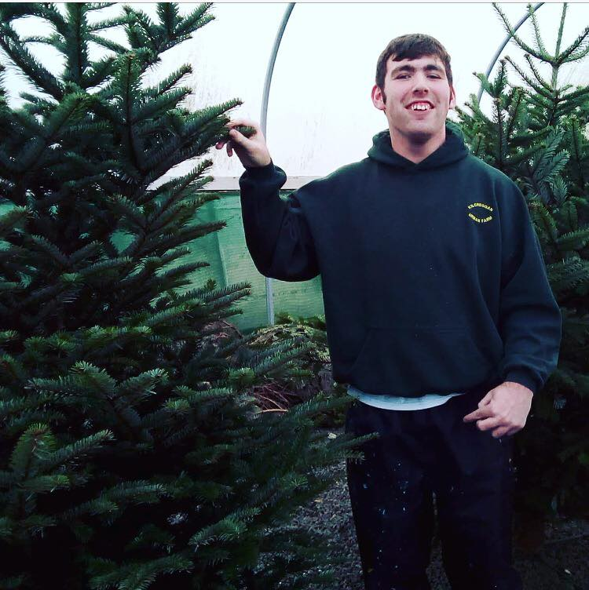  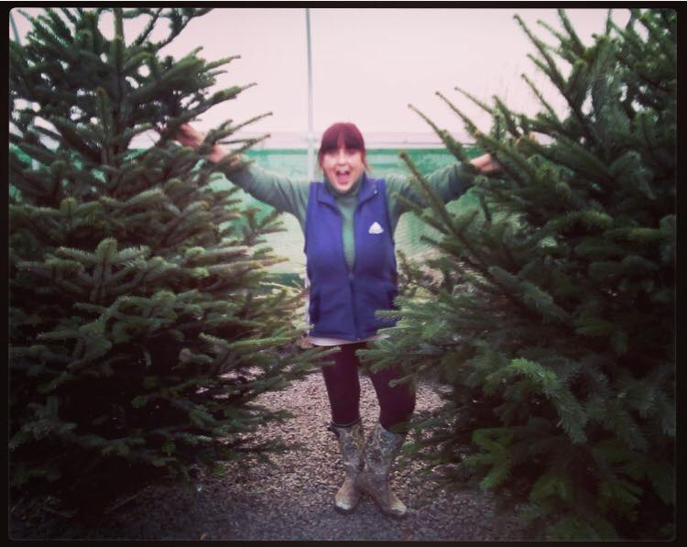  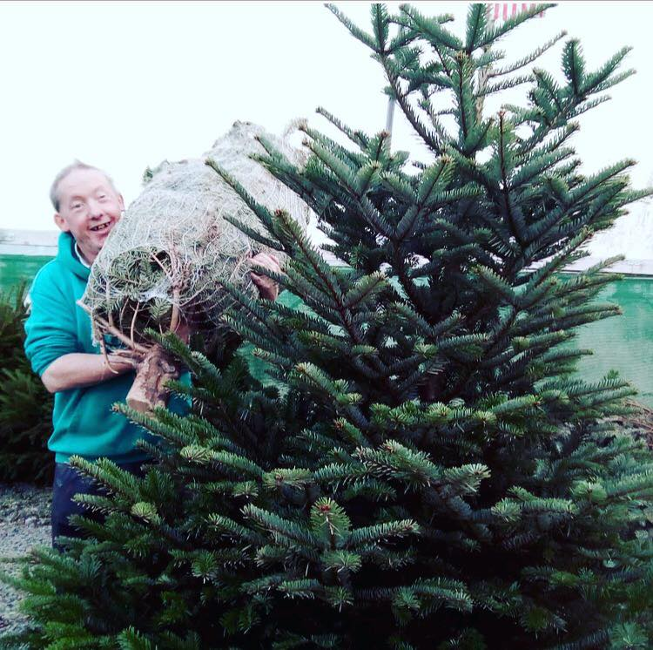  6th december  kilcreggan urban farm  5-8pm  Christmas Open Day 2019  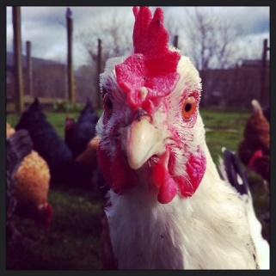  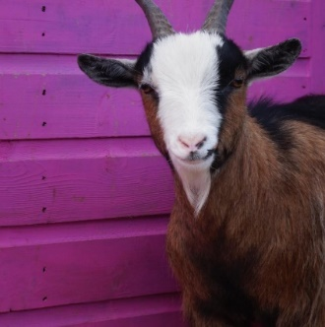  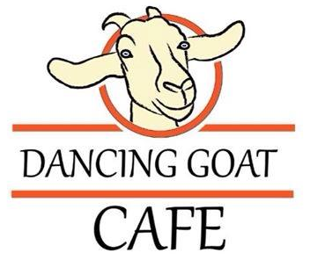  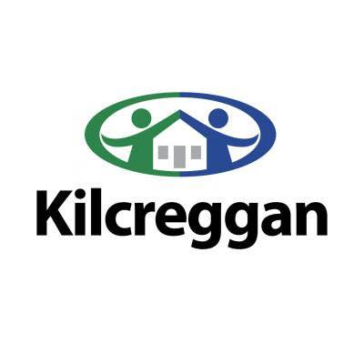  Come along to Kilcreggan Urban Farm on Friday 6th December for a free family open evening. On site, we have will have Christmas craft stalls, Carrick 3rd Silver Band Performance, Smudges Face Painting, Free Kids Christmas Craft, a fabulous range of live music, a BBQ and an opportunity to start the Festive season. Come along, support local and enjoy your visit. | Christmas trees and festive gifts for sale.  FREE!  Smudges Face Painting for kids  ────  FREE Christmas crafts for kids  ────  Live music  Tim Johnston 5-6pm  6pm-6:30pm Hillcroft Makaton Choir  Carrick 3rd Silver Band Performance  6:30pm-7pm  Carrick Sing Choir 7pm-8pm  Kilcreggan Urban Farm  Elizabeth Avenue  BT38 7UY  02893364294  www.kilcreggan.org.uk  8/12/18 10am-3pm

